**GIT CHERRY-PICK :**

1. First will create on master branch index.txt and feature.txt and added and committed this staging and local directory.
2. Created 3 branches from master 1.0,2.0,3.0
3. 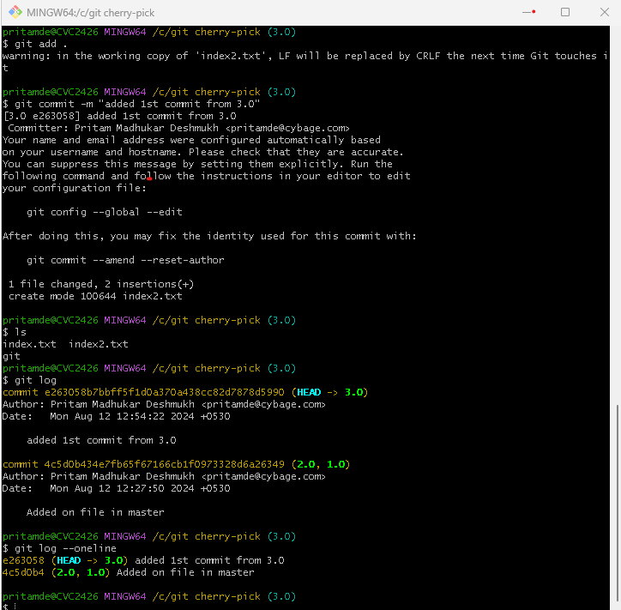
4. Added one commit from 3.0
5. Added another commit with Bugfix file on 3.0 and committed and added to staging and local repository.
6. The same bugfix if we have add for 2.0 and 1.0 then
7. 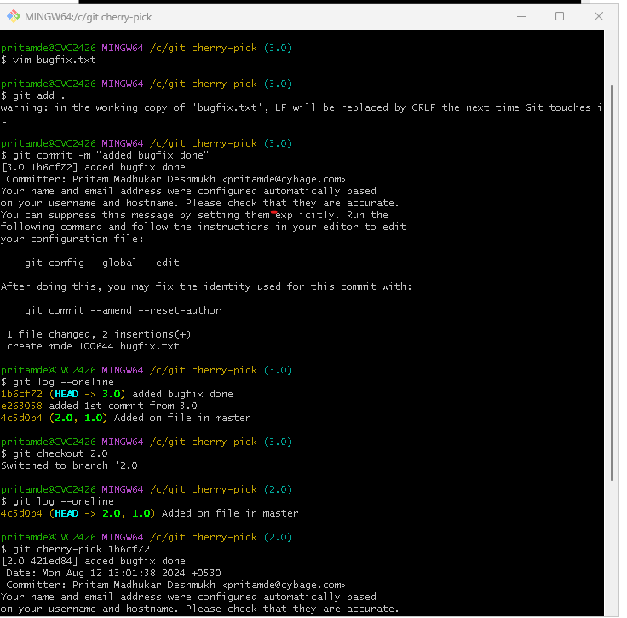
8. Then will checkout branch 2.0 then on that branch cherry-pick particular commits from 3.0

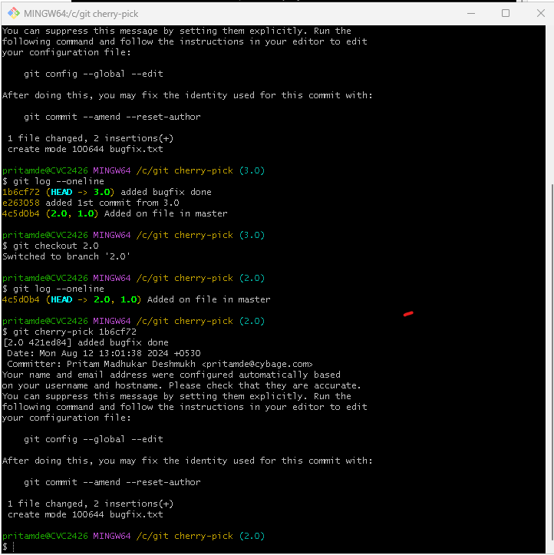

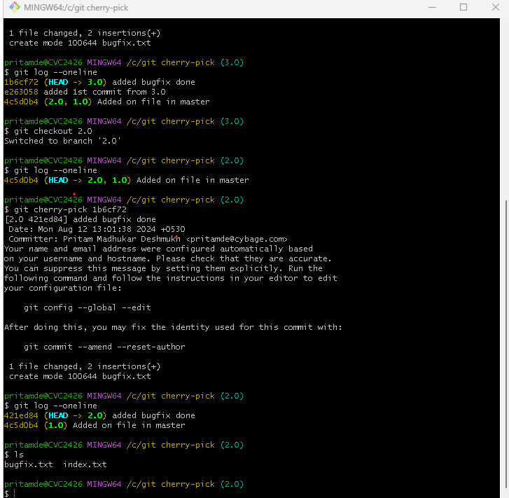

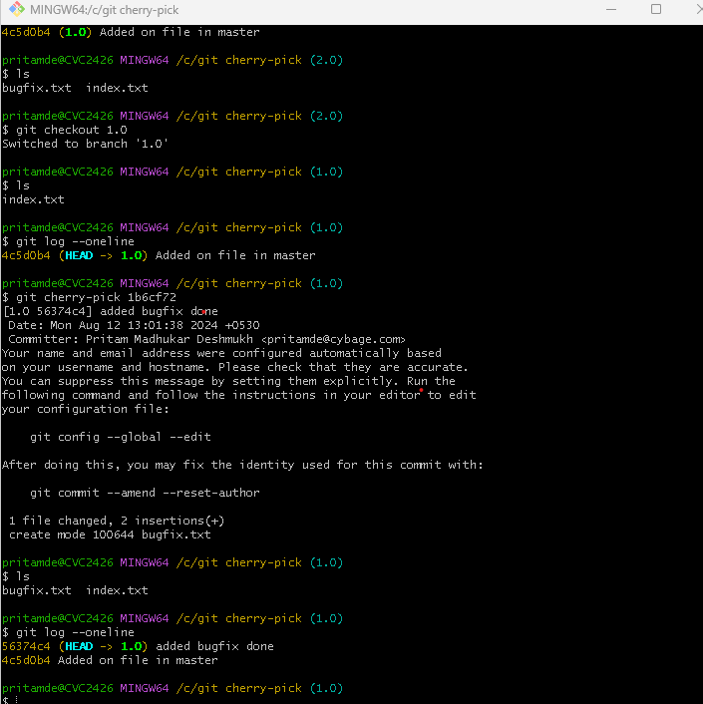

Similarly, we Bugfix this on 2.0 and 1.0 simultaneously so, we can see both files on branches bugfix.txt and index.txt